**Using AWS Cloud Watch, AWS X-Ray and Grafana:**

AWS cloudwatch automatically collects metrics data from applications deployed on AWS and integrates well with a lot of visualisation tools including Grafana, Prometheus, New Relic, Zipkin etc…

Deployed 3 microservices on AWS:

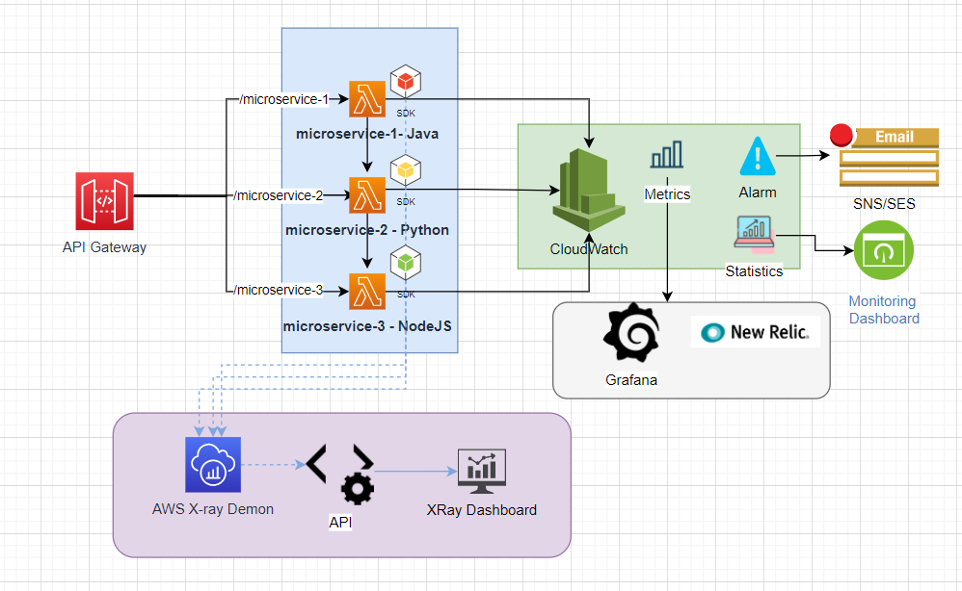

<https://h1amwlhj24.execute-api.us-east-1.amazonaws.com/microservice-1>

The above endpoint calls microservice-1(java) which inturn calls microservice-2(Python) which inturn calls microservice-3(Nodejs)

1. All the services are deployed on lambda exposed via the API Gateway endpoint.
2. Metrics by default are available on cloud watch
3. Since CloudWatch integrates with other APM visualisation tools easily, this approach has been used
4. The logging framework/pattern could well be streamlined using AWS Xray SDK with the polyglot services
5. This is just a simple use case to demonstrate integration with CloudWatch Logs and other APM monitoring tools, so for simplicity AWS Lambda has been used

**Below are some of the screenshots with the metrics:**

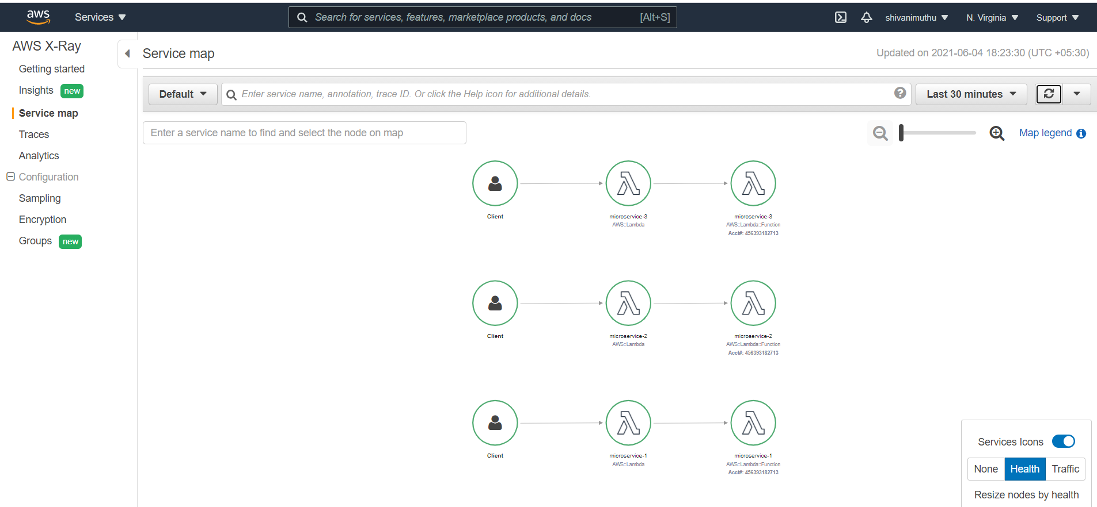

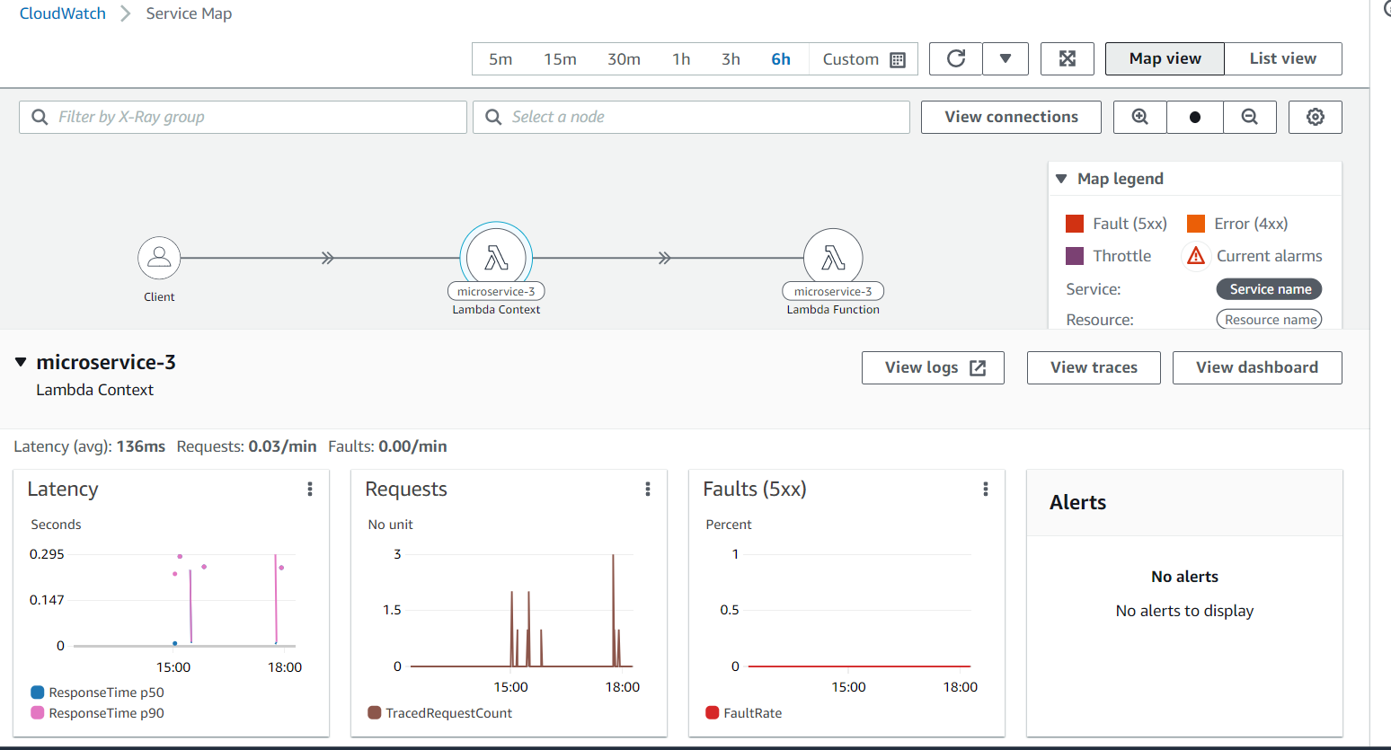

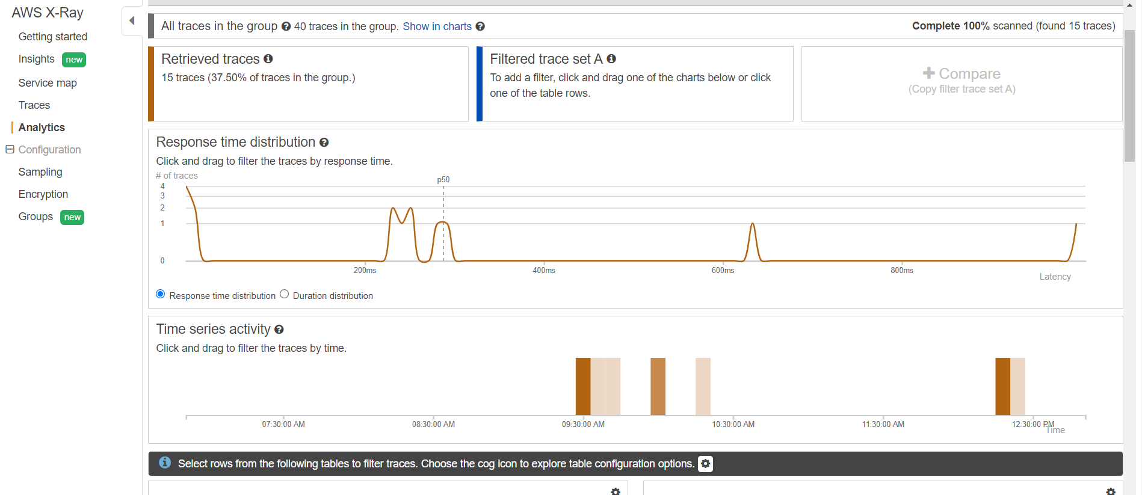

Metrics and logs from cloudwatch streamed ot Grafana:

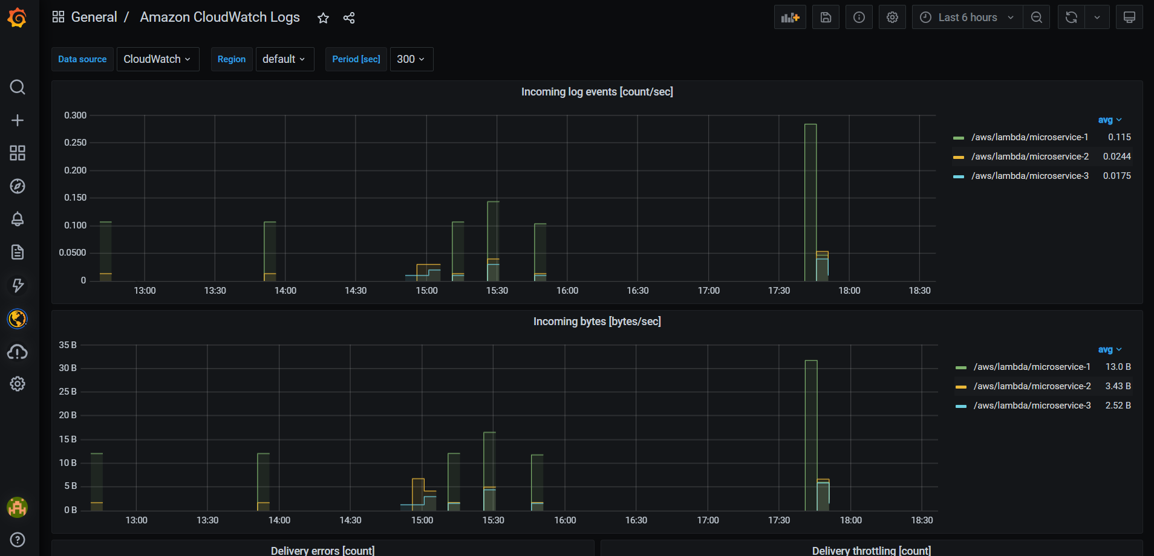

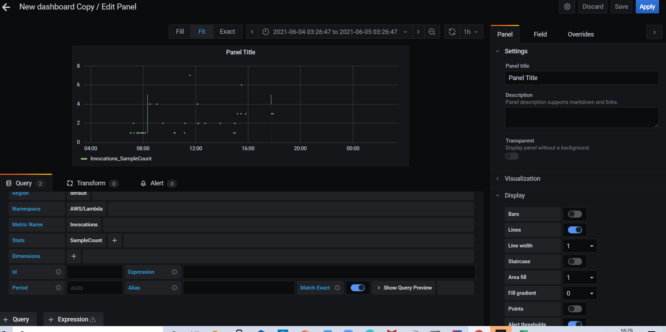

If an ELK stack or zipkin is used, it would require effort from the developer side to set up the Zipkin server, Logstash server, Elastic search server and Kibana. Since AWS provides cloudwatch metrics by default less effort is required for integration with other services and tools.

Using cloudwatch would be a more standardised approach as AWS is a growing Cloud provider, and other tools would definitely provide easy integration solution with AWS

Before coming up with the approach, I tried the below approach of setting up zipkin, which internally uses sleuth for distributed tracing. (Only to later realise that it supports only distributed tracing, monitoritng whether a services is up or not, or Utilization metrics would require integration with ELK). However it could not provide such a wide range of metrics that AWS cloudwatch provides. And zipkin would handle more of distributed tracing and other frameworks would be required to handle the other scenarios for APM

Zipkin approach – Not recommended

I have deployed 3 Microservices as below

Microservice1 (/microservice1) 🡪 calls Microservice2 (/microservice2) -🡪 calls Microservice3 (/microservice3)

To get logs on to Zipkin below is the flow involved:

1. All the 3 microservices use **zipkin** add required headers that enable tracing across microservices. Sleuth intercepts the requests and adds the required **SpanId, TraceId** andthe **timestamp**.
2. Once Microservice1 receives the response, then the log data is send to the zipkin server asynchronously making sure there is no delay in the request-response model
3. An interceptor could be written in zipkin to transfer logs to New Relic through the New Relic agent API

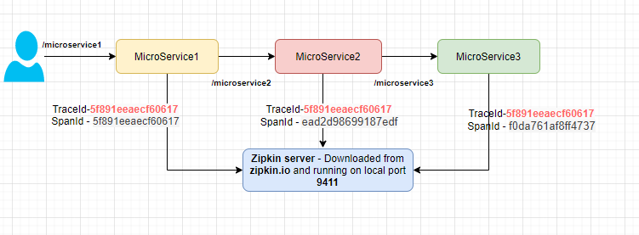

Zipkin is available as an sdk aross various languages and can be used as a monitoring solution. The overhead of using zipkin is the configuration and maintenance required to stand-up your own zipkins server

